**Networking classroom notes**

to communicate we need to connect two hosts directly or indirectly

all network applications are client-server based

eg: email, www

all applications should follow protocol

examples: http, pop, smtp, ftp, telnet

types of network:

LAN - local area network (room or building)

WLAN - Wireless Local Area Network

WAN - wide area network

used to connect 2 LANs spread accross globally

belong to same organization

connect using leased lines

MAN - Metropolitan Area Network (form of WAN)

CAN - network within the campus(form of WAN)

Internet - public network (network of networks)

VPN - Virtual Private Network

helps in private communication using internet

tunnel created within internet

Topography: how systems connected within LAN

Peer-to-Peer 2 systems are cabled with each other

Bus topology

all systems connected using single backbone cable

all systems allowed to send data

possibility of data collision

Ring topology

also refered as token ring topology

a token keeps going around

any system catches that token has right to send data

no possibility of collision

very slow as only one system can send data at a time

Start topology

most efficient topology

network latency (delay) does not depened on number of hosts

can be extended to extended star topology

devices like hub and switch are used at the centre of star

hub is not intelligent. data received from one system is sent to all other systems

(broadcast)

switch selectively release the data through the port on which the receiver is connected

WAN connection

multiple LANs are connected in WAN

every LAN connected to a router which is a gateway to outside

multiple LANs connected to a router

On each router interface another LAN or another router is connected

Address types in networking

physical address

permamnent address. comes with the device

48 bit binary number

unique in the entire world

Known as MAC address

within LAN devices identified through MAC address only

logical address

IP address (IPv4 or IPv6)

temporary addresses

can be configured and changed any time

IPv4 - 4 octets of 8 bit each (32 bits)

eg: 124.56.78.91

IPv6 - 128 bit address (8 sets of 16 bits)

IP address is required when communicating beyond LAN for routing

Communication always needs IP address

Within LAN systems are identified with MAC address

DNS - DomainNameService

domain names are used for easy reference (eg: oracle.com)

not possible to have communication using domain names

while sending data IP address is a must

DNS servers help in translating domain names into IP addresses

**OSI reference model**

7 layers of specification for network

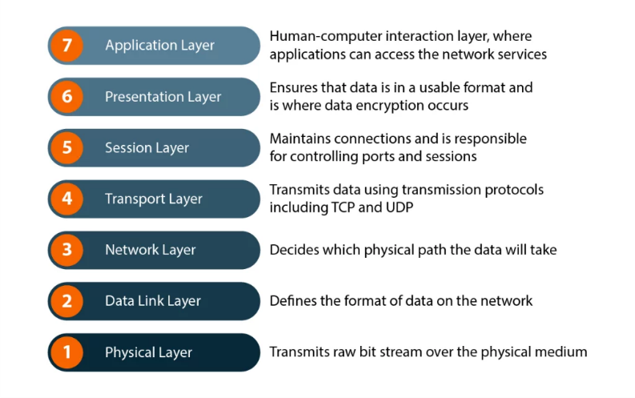

1. Application Layer

near to the user

uses application protocols

IP address is required to send request

every application uses one port(numeric value assigned for this application)

2. Presentation Layer

handles data conversion(ASCII to EBCDIC and back)), data compression etc

encryption / decryption can also happen in this layer

does not bother about addresses

3. Session Layer

allows to maintain session between two systems(sender and receiver)

starts with iniutial handshake

session start and session termination happen at this layer

4. Transport Layer

convert message into multiple packets

each packet contains sno, sender ip address, receiver ip address and data

uses servicepoint address(port address) for correct delivery to the specific process

uses TCP / UDP protocols

TCP: guarantees delivery

UDP: There is no guarantee for delivery

5. Network Layer

Decides which route is used for sending data

Device: router

6. Data link Layer

Belongs to LAN

Decides the ultimate delivery

Deals with MAC address

Creates frame for delivery

Device: switch

7. Physical Layer

Consists of bit transmission

Device: Cables, connectors etc

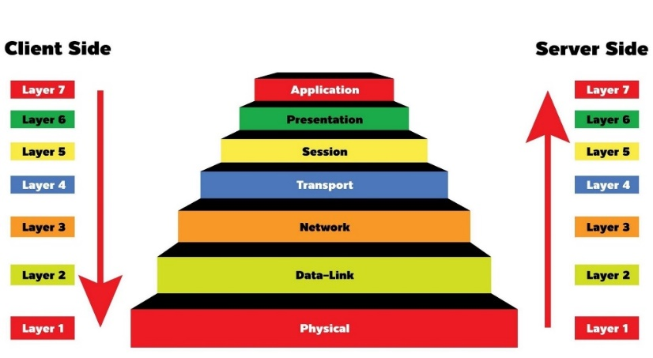

**TCP/IP Model**

TCP/IP model is implementation for internet

It adapts to OSI model with some changes

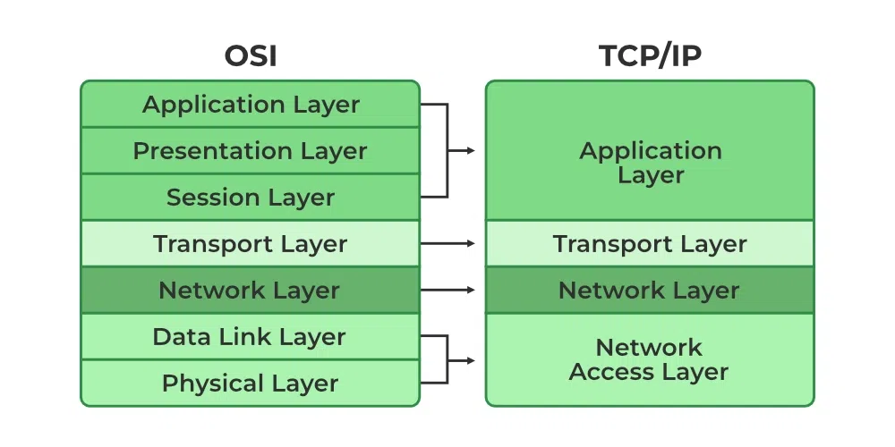

**IP Address Classes**

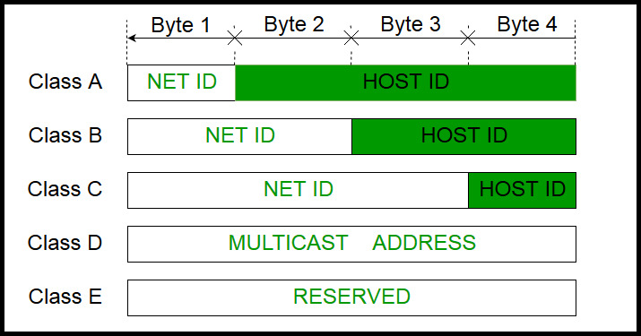

class A - start with 0 - first octet 1 to 126 - subnet mask 255.0.0.0

class B - start with 10 - first octet 128 to 191 - subnet mask 255.255.0.0 (127 reserved for loopback)

class C - start with 110 - first octet 192 to 223 - subnet mask 255.255.255.0

class D - starts with 1110 - multicast

class E - starts with 1111 - reserved for experimental and research purposes

when we talk of IP address we should know the following

network address (zeroes in host portion)

broadcast address (all 1s in host portion)

IP address

Subnet mask (all 1s in network portion and all 0s in host portion)

Example:

196.21.34.62

Network address -> 196.21.34.0

Broadcast address -> 196.21.34.255

IP address 0> 196.21.34.62

Private addresses

10.0.0.0 to 10.255.255.255

172.16.0.0 to 172.31.255.255

192.168.0.0 to 192.168.255.255

Subnetting:

Borrowing bits from host portion and add them to network portion